Risk assessment template – Transporting children (other than as part of an excursion)

Children are sometimes transported by, or on transport arranged by, children’s education and care services. For example, this might include transport to and from the service premises or other location and a child’s home. Service providers, nominated supervisors and educators need to take specific steps to ensure the health, safety and wellbeing of children.
Under the Education and Care Services National Regulations (r 102B), a transport risk assessment must be conducted before an education and care service transports a child / children (other than as part of an excursion*).
ACECQA has prepared this template to assist service providers, nominated supervisors and family day care educators in undertaking risk assessments before transporting children, which services may wish to incorporate within their own risk assessment material.
Note: A risk assessment is only required to be completed at least once for a 12 month period if it is ‘regular transportation**’.
* Regulation 101 includes the minimum risk assessment considerations for excursions by approved providers, nominated supervisors and family day care educators. This includes specific considerations when an excursion involves transporting children. A separate template to assist service providers, nominated supervisors and family day care educators in undertaking risk assessments before an excursion can be found here.
** Regular transportation is transport by the service or arranged by the service (other than as part of an excursion) of a child being educated and cared for by the service, where the circumstances relevant to a risk assessment are substantially the same each time the child is transported. [An example of a change in circumstances that are substantially different might be when the means of transport or the transportation route or destination(s) have altered or the provider of the transportation service has changed.]

Service name | New Lambton District OOSH Before School Transport Risk Assessment
Activity  E.g. collecting children from school or home | Collection of children from New Lambton District OOSH on the grounds of New Lambton South Public School and transport to New Lambton Public School
Start date: 29th Jan 2021 | End date: 17th Dec 2021
Pick-up location and destination(s)  Include each location travelled to or from  E.g. each child’s home address or each school | Pick up: New Lambton District OOSH, New Lambton South Public School, St James Rd, New Lambton, 2305  Destination: New Lambton Public School, Regent St, New Lambton, 2305
Estimated time of travel between the different locations  E.g. Departing the service, arriving at children’s homes or schools and arrival at the service | 8.40am - 9am
Proposed route  You can include an image of the route sourced online | 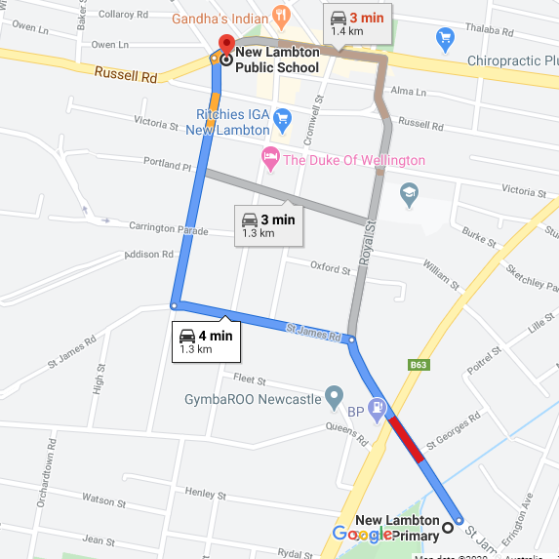
Means of transport  E.g. public bus, private bus, coach, private car, taxi, tram | Port Stephens Coaches
Requirements for seatbelts or safety restraints in your state or territory have been met | Yes / No  Comment: If the coach that is provided by Port Stephens has safety restraints educators will ensure they are worn
Number and full names of each adult involved in the transportation of children | Maximum of 5 educators depending on 1:15 ratio  Bus roster changes on a daily basis.
The number of educators / responsible adults, appropriate to provide supervision and whether any adults with specialised skills are required  E.g. for children’s individual needs | Maximum of 5educators depending on 1:15 ratio
The number of children being transported | 75 maximum
Any water hazards on proposed route travelled and at each stop?  E.g. Bridge, causeway, risk of flooding, beach, lake, dam | Yes / No  Comment: Low risk at times of heavy rainfall. An alternative route may need to be taken, this will be at the discretion of the bus driver and bus leaders.
Describe the process for entering and exiting the service premises and the pick-up location or destination (as required);  (include how each child is accounted for) | The New Lambton Public children are gathered at 8.40am at New Lambton District OOSH and marked on the paper roll in separate Infants and Primary groupings. Children will be supervised as this is occurring. Once all children are accounted for they are escorted to the bus which is waiting at the bus stop on St James Rd.
Describe the procedures for embarking and disembarking the vehicle; (include how each child is accounted for in embarking and disembarking) | As the children enter the bus they are marked off the rolls for a second time in alphabetical order to ensure they are present. The bus then alights for New Lambton Public School.  To disembark the bus at New Lambton Public School 2 educators will disembark first with one educator waiting at the bottom of the bus steps while the other leads the children to the school gate. Children are kept away from the road side as they walk to the gate. An educator will be the last to leave the bus and will ensure there are no children or belongings left on the bus.  All children are then marked off the electronic sign in as having left the service.  Once all children have safely entered the school ground the educators return to the bus for the trip back to NLDOOSH.
Transport checklist – items to be readily available when transporting children
(please tick)
□ First aid kit | □ List of adults involved in transportation
□ List of children involved | □ Contact information for each adult
□ Contact information for each child | □ Mobile phone / other means of communicating with the service & emergency services
□  Medication, health plans and risk assessments for individual children | □ Other items, please list

Use the table below to identify and assess risks to the safety, health or wellbeing of children being transported, and specify how these risks will be managed and minimised [regulation 102C(1)].
Risk assessment
Activity | Hazard identified | Risk assessment  (use matrix) | Elimination/control measures | Who | When
Transportation | Ventilation | Low | Open windows  Air-Conditioning | All Staff rostered on bus | Ongoing
Transportation | Missing Children | Medium | To follow our set Policy and procedures of:  Bus Procedure  Transportation Policy  Delivery and Collection of Children Policy  Electronic Sign In Procedure | Bus Leader | Ongoing
Transportation | Trips and Falls in school ground,  Slips on bus steps  Injuries to children | Medium | Supervision of children  Carrying first aid kits  Remove any foreseen hazards  All staff have walkie talkies and mobile phones to communicate  Staff positioned at the bus entry to assist children  All children to be seated on the bus | All Staff rostered on the bus and children | Ongoing
Transportation | Vehicle accidents | Low | Keep noise to a minimum on the bus  All children and staff to wear seat belts where provided.  All children to remain seated at all times  Constant supervision | All Staff rostered on the bus and children | Ongoing

Risk Matrix
 |  | Consequence
Likelihood | Insignificant Minor Moderate Major Catastrophic  Almost certain Moderate High High Extreme Extreme  Likely Moderate Moderate High Extreme Extreme  Possible Low Moderate High High Extreme  Unlikely Low Low Moderate High High  Rare Low Low Low Moderate High

Plan and Review
Plan prepared by:  Sue-anne Bull  Peta Winney-Baartz  Nicole Bain  Fiona Mayers | Full name:  Signature:  Role/Position: | Date:
Prepared in consultation with: Management Committee | Full name:  Signature:  Role/position:
Communicated to all relevant staff: | Yes / No  Comment if needed:
Vehicle safety information reviewed and attached | Yes / No  Comment if needed:
Risk assessment to be evaluated and reviewed on:  A risk assessment must be undertaken each time the service transports, or arranges, the transport of children (other than as part of an excursion). If the transport is for 'regular transportation'*, a risk assessment must be undertaken at least annually. | Dec 2020

